Smart Peer Tutoring & Session Matching App

1. Description of Implemented Modules
The application is built using a Flutter frontend and a Node.js/Express backend connected to a MongoDB database. It utilizes an Offline-First Architecture ensuring users can interact with the app even under poor network conditions. The core modules implemented are:

Authentication & Profile Module
Secure Registration & Login: Users can securely sign up using email and password. The backend utilizes bcryptjs for strong password hashing before saving to MongoDB.
Role-Based Profiles: Users can register as a Learner, Tutor, or Both. The profile stores their specific subjects, skillLevel, and availability time slots.
Offline Persistence: Upon login, the user's data is cached locally using Hive. If the app is restarted without an internet connection, the user remains logged in securely.
Tutor Discovery & Listing Module
Dynamic Search & Filtering: A central feed where learners can browse available peers. It includes real-time filtering by Subject, Minimum Rating, and Skill Level.
Match Ranking: The list isn't just alphabetical; it intelligently ranks users based on their relevance to the currently logged-in learner (detailed below).
Session Booking & Management Module
Conflict Prevention: When a learner attempts to book a session, the system checks both the learner's and the tutor's existing schedules to prevent double-booking in the same time slot.
Lifecycle Tracking: Sessions move through states (scheduled -> completed or cancelled), giving users a clear dashboard of their upcoming and past tutoring commitments.
Feedback & Rating Module
Post-Session Reviews: Once a session is marked as completed, learners can leave a star rating and written feedback.
Dynamic Score Recalculation: When new feedback is submitted, the backend automatically recalculates the tutor's average rating and total session count, dynamically updating their profile across the platform.
Offline Synchronization Engine
Local Caching: Using Hive, all critical data (Users, Sessions, Feedback) is stored locally.
Network Detection: The ConnectivityService monitors network status. If the user performs an action (like booking a session) while offline, it is flagged as isSynced: false. Once the network returns, the app silently flushes these changes to the backend.
2. Explanation of Matching Logic
The matching algorithm is designed to connect learners with the most relevant and highly-rated peers. It is implemented in the TutorProvider (lib/providers/tutor_provider.dart).

The logic operates in two phases: Filtering and Scoring.

Phase 1: Hard Filtering
When a user applies filters via the UI, the list of all users is narrowed down using strict boolean checks:

Subject Query: Only includes tutors who list the exact searched/filtered subject.
Skill Level: Only includes tutors who match the explicitly requested skill level.
Availability: Checks if the tutor's availability array contains the specific time slot selected by the user.
Phase 2: Algorithmic Scoring & Sorting
If no strict UI filters are applied, the app defaults to showing all available peers, but it sorts them intelligently based on the learner's profile using the _matchScore function:

Dart
double _matchScore(UserModel tutor, UserModel? learner) {
if (learner == null) return tutor.rating;

// Calculate how many subjects the tutor and learner share
final subjectOverlap = tutor.subjects.where((s) =>
learner.subjects.any((ls) => ls.toLowerCase() == s.toLowerCase())
).length;

// Score formula: (Tutor's Rating) + (Overlapping Subjects * 0.5 weight)
return tutor.rating + (subjectOverlap * 0.5);
}
How it works:

Baseline Quality: The tutor's current average star rating serves as the base score.
Relevance Multiplier: The algorithm compares the logged-in learner's subjects with the tutor's subjects. For every matching subject, the tutor gets a 0.5 point boost.
Result: A brand new tutor (0 rating) who shares 4 subjects with the learner will score a 2.0 and rank higher than a 1.5-star tutor who shares 0 subjects. This ensures that relevance is prioritized alongside historical quality.
3. Future Scope
While the current implementation fulfills all core requirements, the application is designed to be highly scalable. Future enhancements could include:

Real-time Chat & WebRTC: Integrating Socket.io and WebRTC to allow students to communicate and conduct video tutoring sessions directly within the app.
AI-Powered Matching: Replacing the current heuristic overlap algorithm with a machine learning model that analyzes past successful sessions, learning styles, and user behavior to predict the best peer matches.
Push Notifications: Integrating Firebase Cloud Messaging (FCM) to alert users when a session is booked, cancelled, or about to start.
Payment/Token Integration: Introducing a virtual token economy where tutors earn points for teaching, which they can later spend to hire other tutors for subjects they struggle with.
Calendar Integration: Syncing scheduled sessions directly with the user's native Google or Apple Calendar.

4. Screenshots of all UI screens
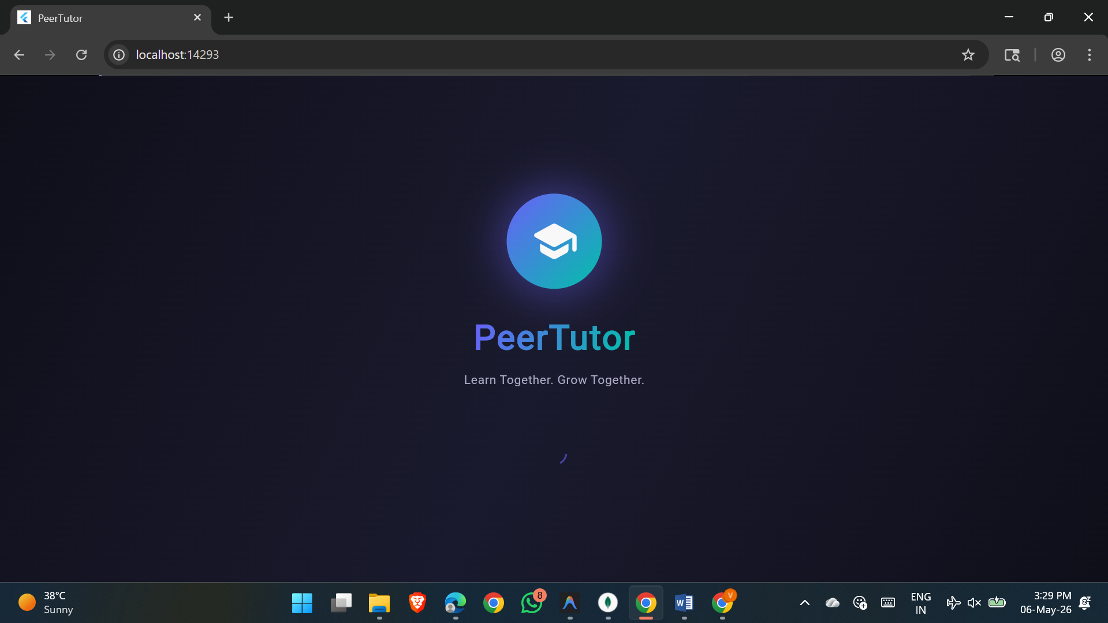
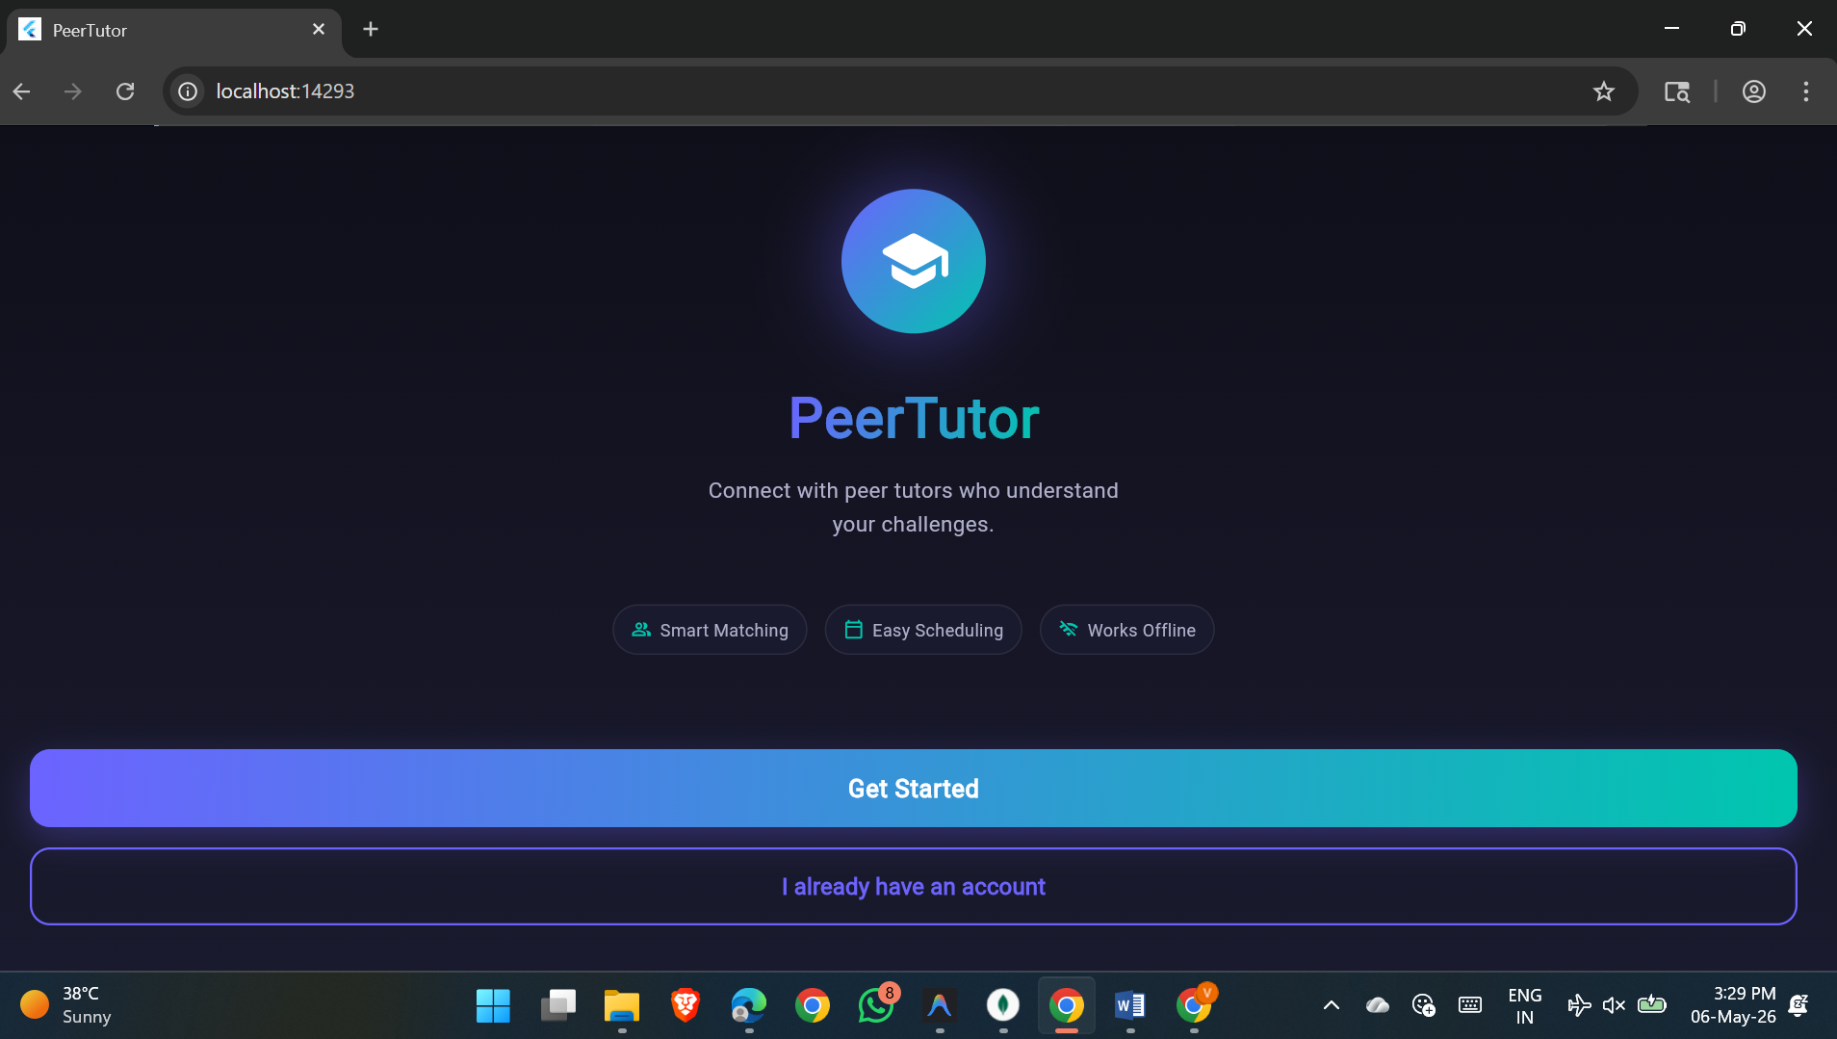
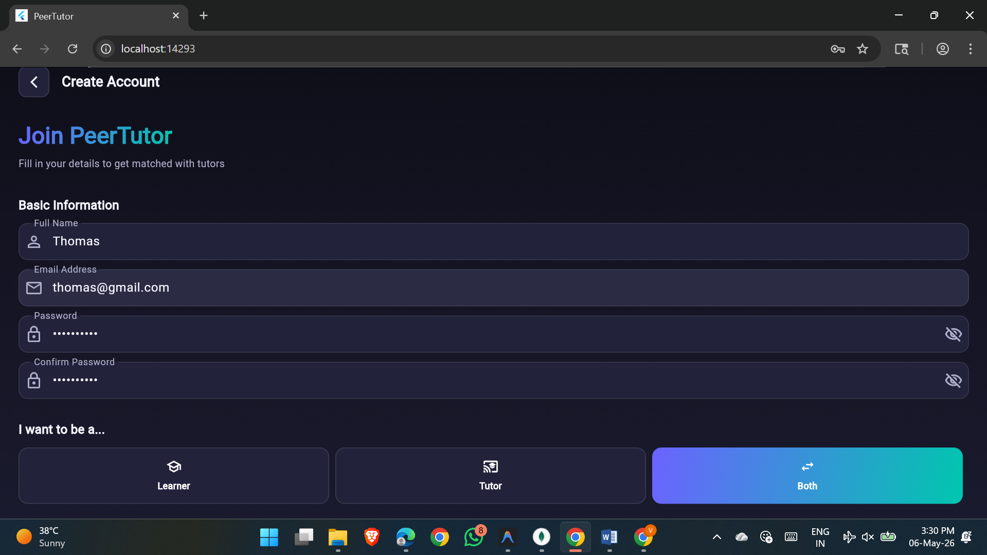
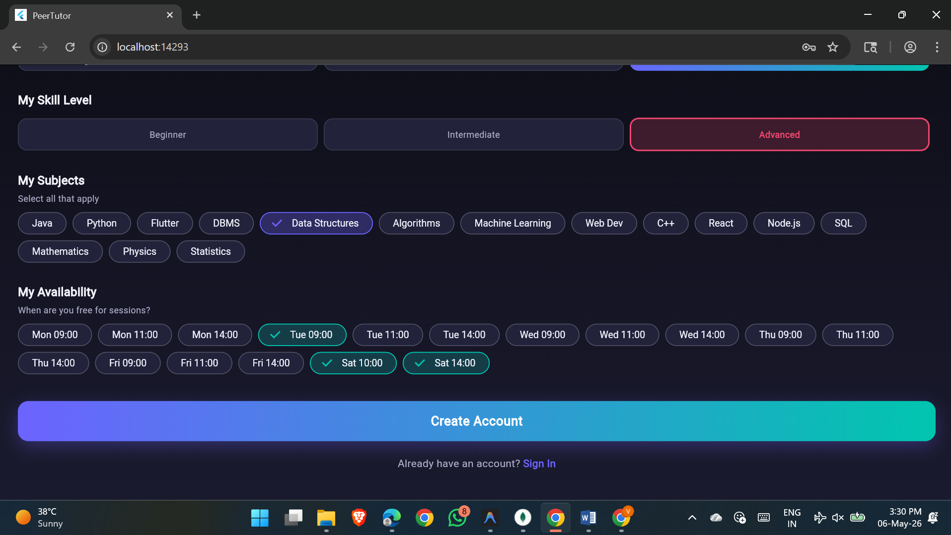
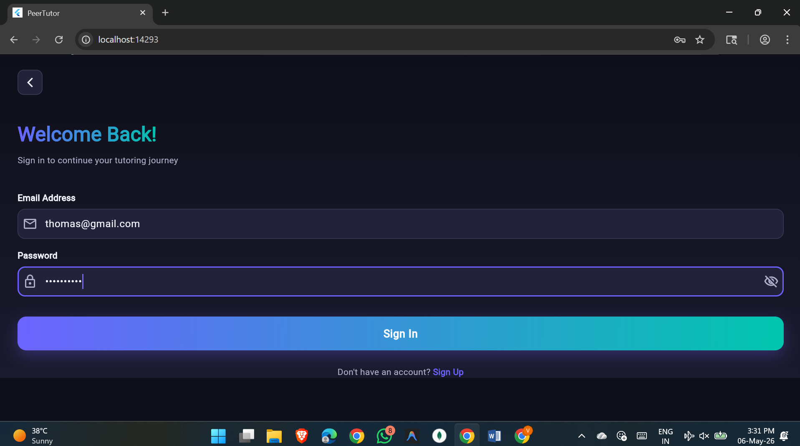
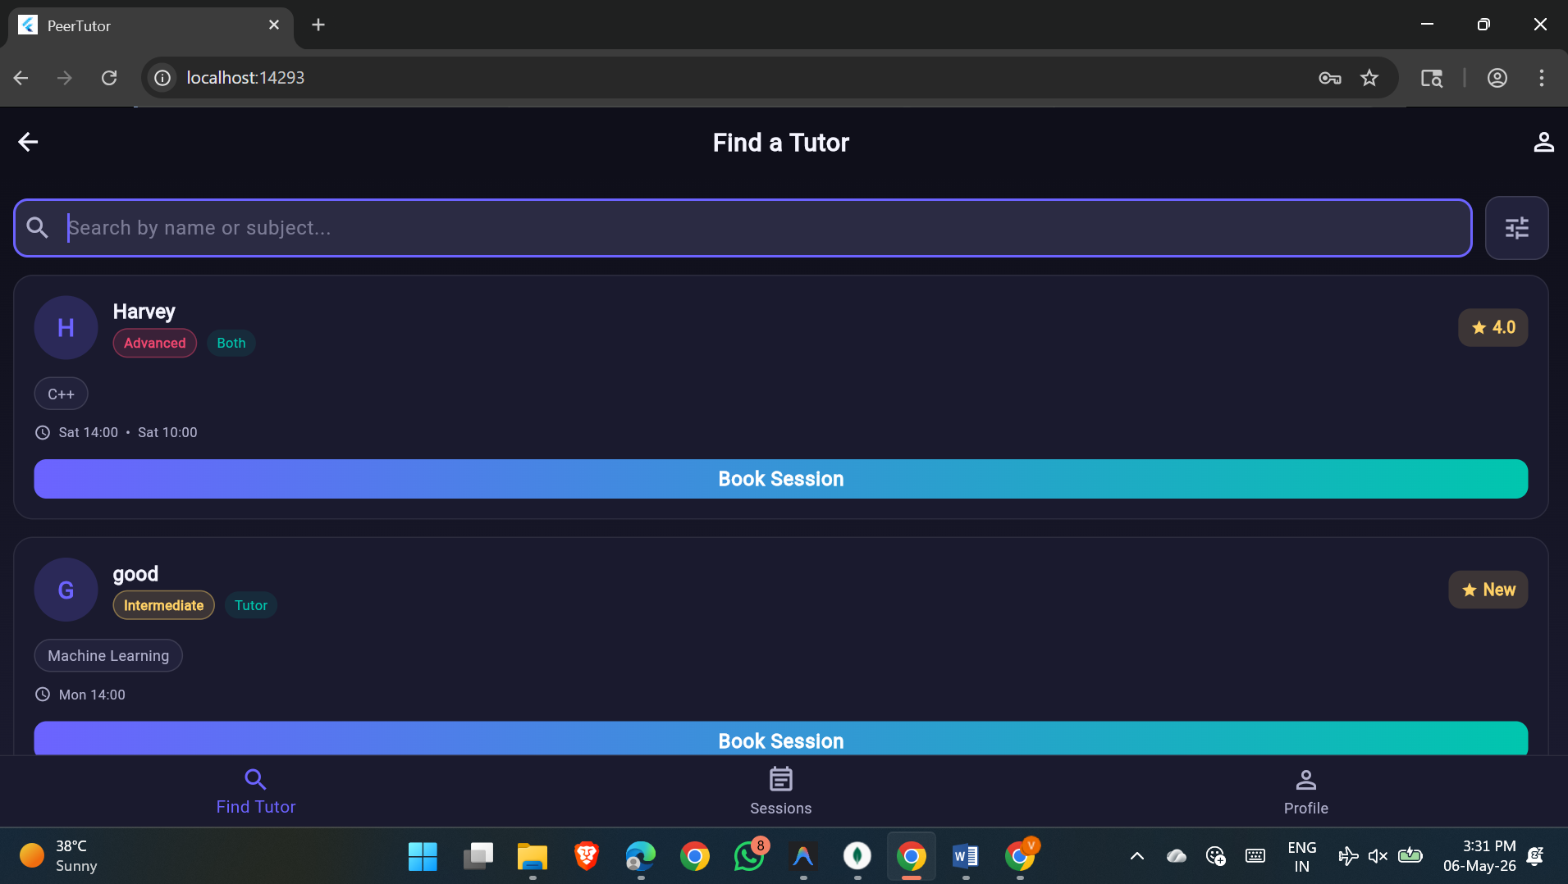
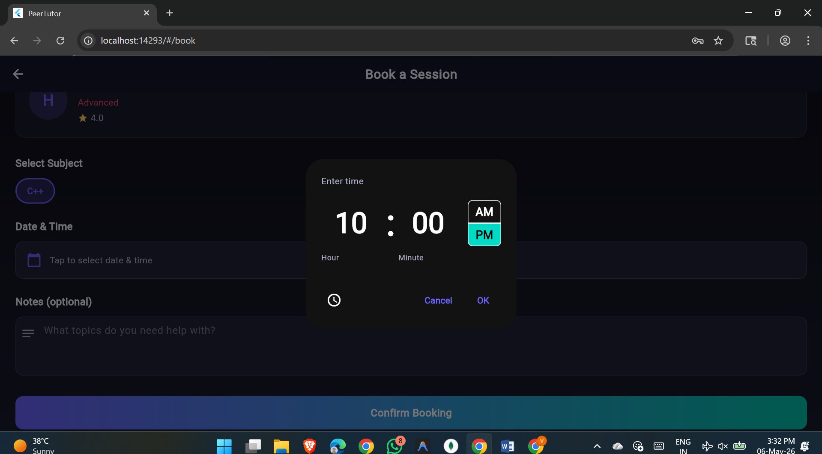
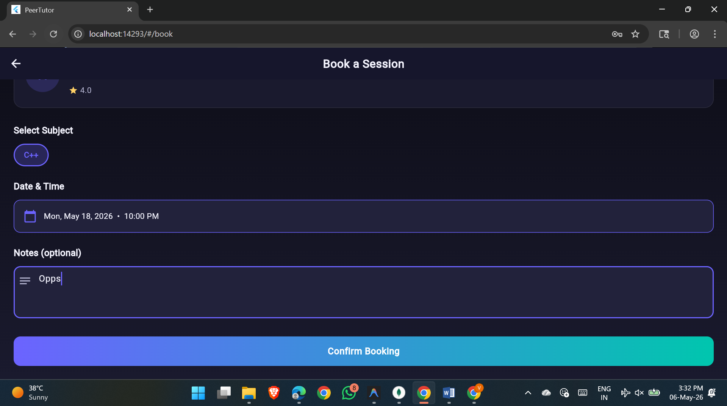

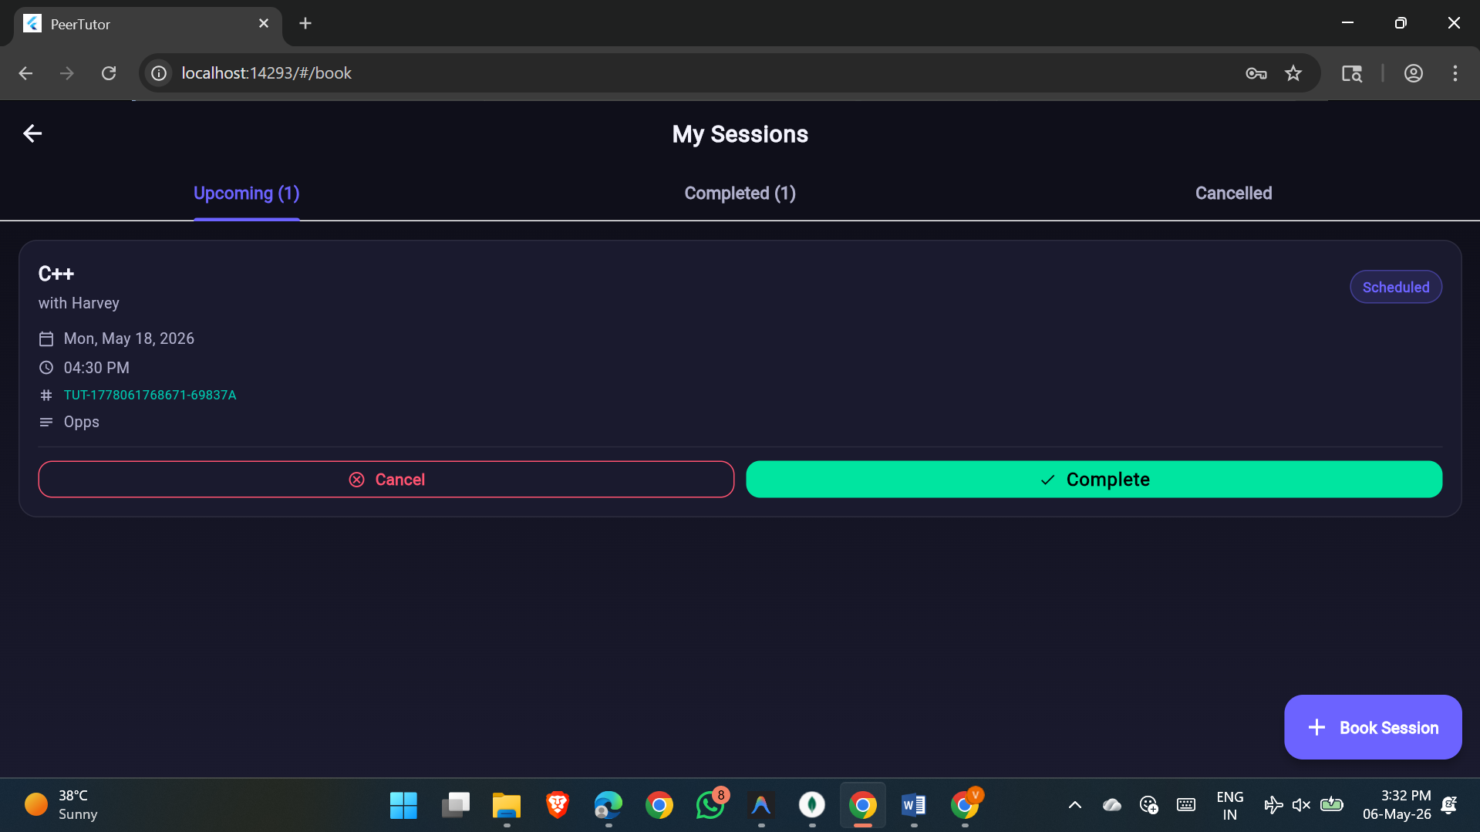
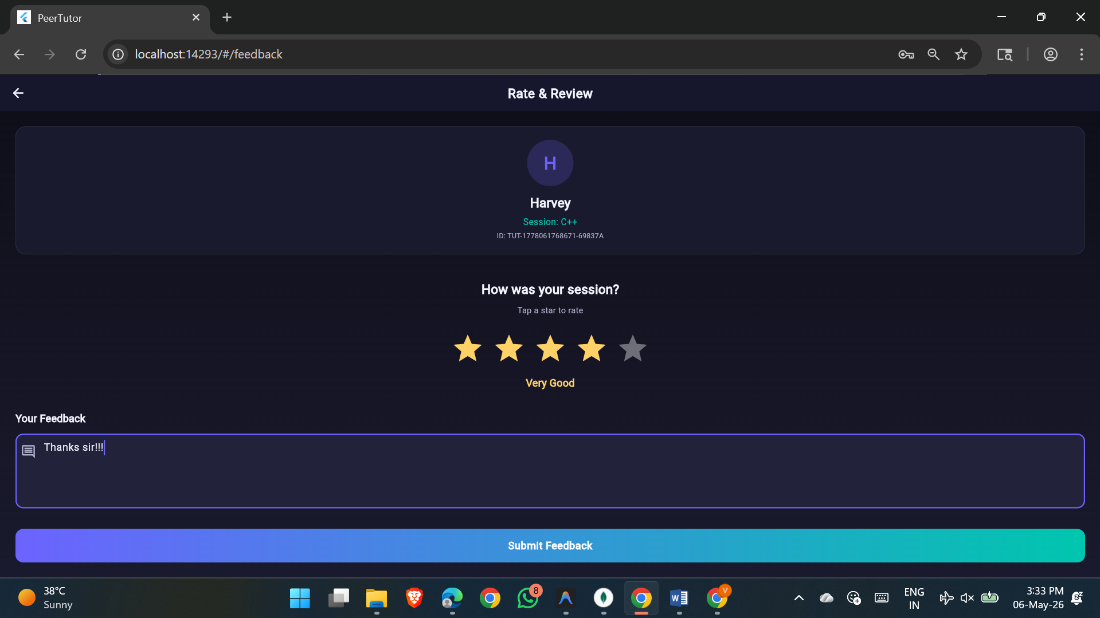
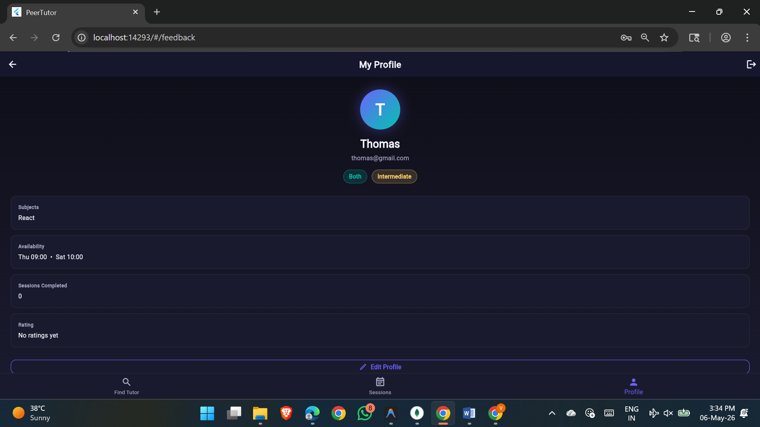

5. Conclusion
The Smart Peer Tutoring & Session Matching App successfully bridges the gap between students needing academic help and peers willing to teach. By implementing a robust Node.js backend alongside a highly responsive, aesthetically pleasing Flutter frontend, the platform provides a seamless user experience.
The integration of an Offline-First architecture using Hive ensures that university students with spotty campus Wi-Fi are never locked out of their schedules. Furthermore, the intelligent matching algorithm guarantees that users are presented with the most relevant help immediately, eliminating the friction usually associated with finding academic support.
This project demonstrates a complete, end-to-end full-stack mobile application capable of solving real-world educational collaboration challenges.

